Password Manager Design Document

# Classes

Please see the UML for more in depth class design concepts, including methods and attributes

* main
  + the main loop of the program, executes the window, and houses UI elements
* Safe
  + Contains the list of keys, and executes high-level functions of the program like adding and removing keys
* Key
  + Contains all the relevant information for a specific entry, including a username and a password
* Password
  + Contains low-level data about a specific password, and encrypts and decrypts it for the user

# UML Diagram

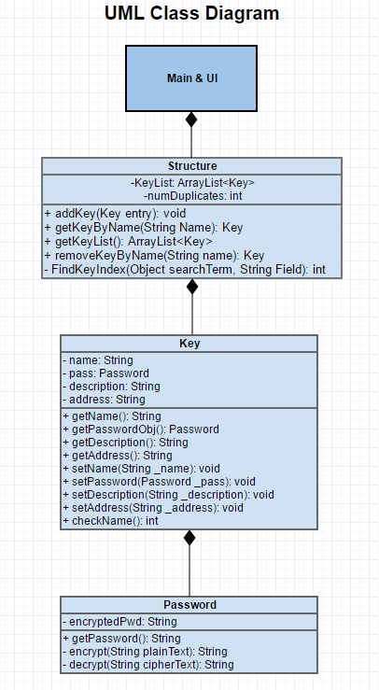

# State Diagram

